Requirements/Design Specification

**July2015 GH481**

**CSA Signed - Signed Republic Agreement or Third Party**

**(CR 14083)**

Revision History

|  |  |  |  |
| --- | --- | --- | --- |
| **Date** | **Revision** | **Description** | **Author** |
| 5/18/2015 | 1.0 | Initial Version with Requirements | Gaurav Dawar |
|  |  |  |  |
|  |  |  |  |
|  |  |  |  |
|  |  |  |  |

The information furnished herein by Republic Services Inc. is proprietary and confidential to Republic Services Inc. personnel and is not to be duplicated, published, or disclosed to any third party in whole or in part without permission from Republic Services, Inc.

© Copyright 2012, Republic Services Inc. - All rights reserved.

Table of contents

1 Business Requirements 6

1.1 Purpose of the Design Specification 6

1.1.1 Bug list for current release 6

2 Competitor Overview and Assumptions 6

3 Design 6

4 Impacted Systems (InfoPro, TIBCO and BI) 8

5 Report Changes 8

6 Appendix 8

# Business Requirements

## Purpose of the Design Specification

This document highlights items to be fixed and implemented for the titled release.

### Bug list for current release

| GitHub Item  Number | **Description** |
| --- | --- |
| 481 | CSA Signed - Signed Republic Agreement or Third Party (CR 14083) |

# Overview and Assumptions

Since there is already a radio button option on the finalize page which says “Customer Accepted: Signed”, Sometimes sales reps checks this radio button even when customer is signing a third party agreement or if they have an old signed contract with republic.

# Design

## #481 CSA Signed - Signed Republic Agreement or Third Party (CR 14083)

Solution to this issue is that we introduce another radio button on finalize page “Customer Accepted: Signed third party agreement” and also change the existing “Customer Accepted: Signed” to something which explains that this radio button is to be selected only when customer is signing the contract associated with the quote just created in the capture. Also, as per Brittany and MDM when “Customer Aceepted : Signed third party agreement” is selected then contract status is to be over ridden by “08”. We have a confirmation from MDM that the “08” contract status option will be in and allowed to be used in infopro at the end of May 2015.

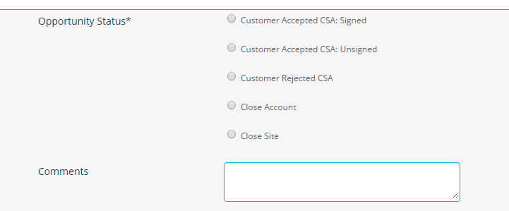

Also, Made changes to the rules :

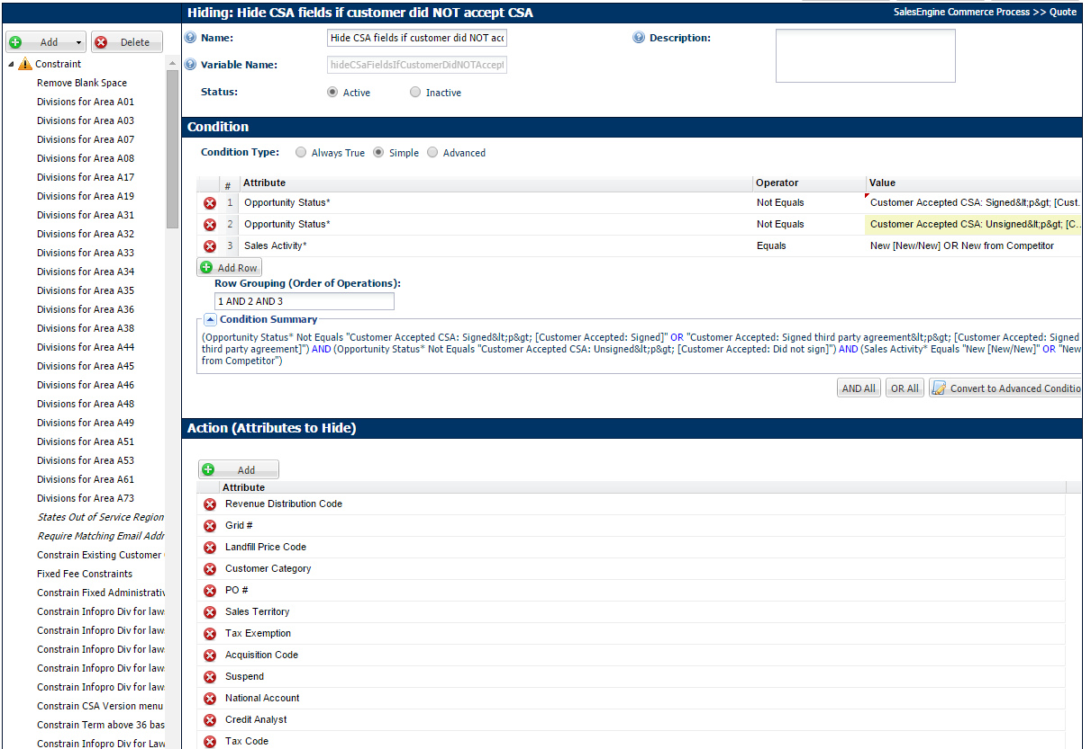

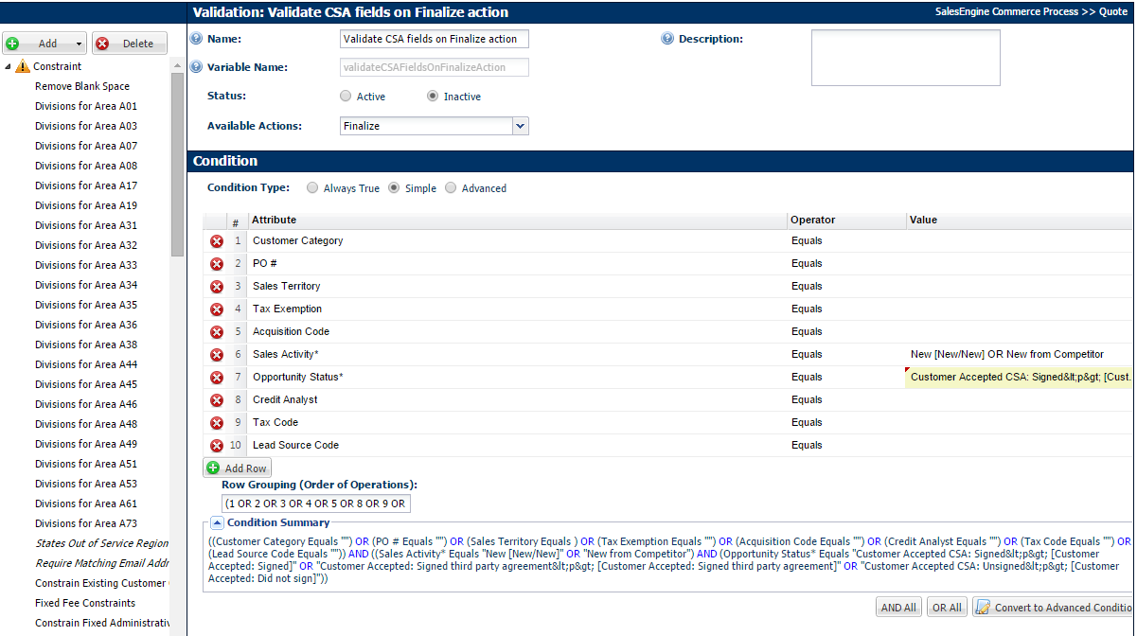

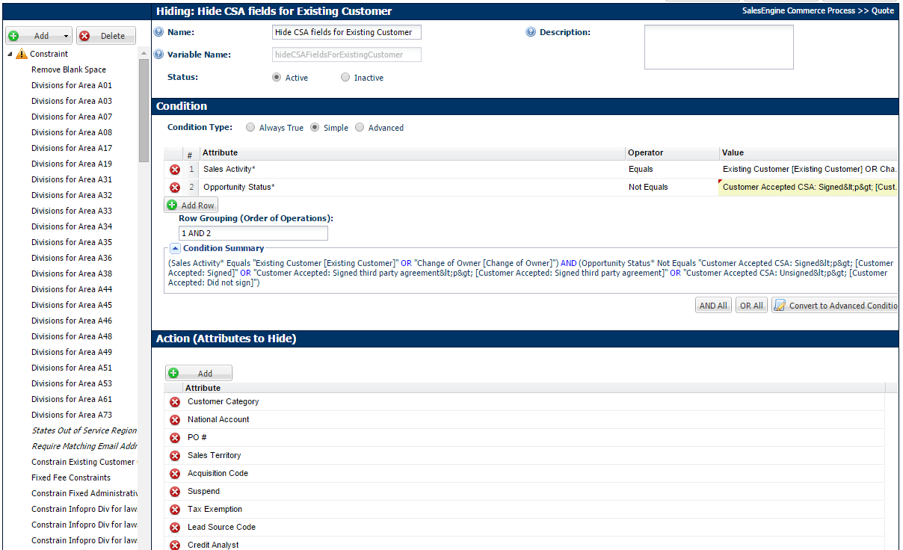

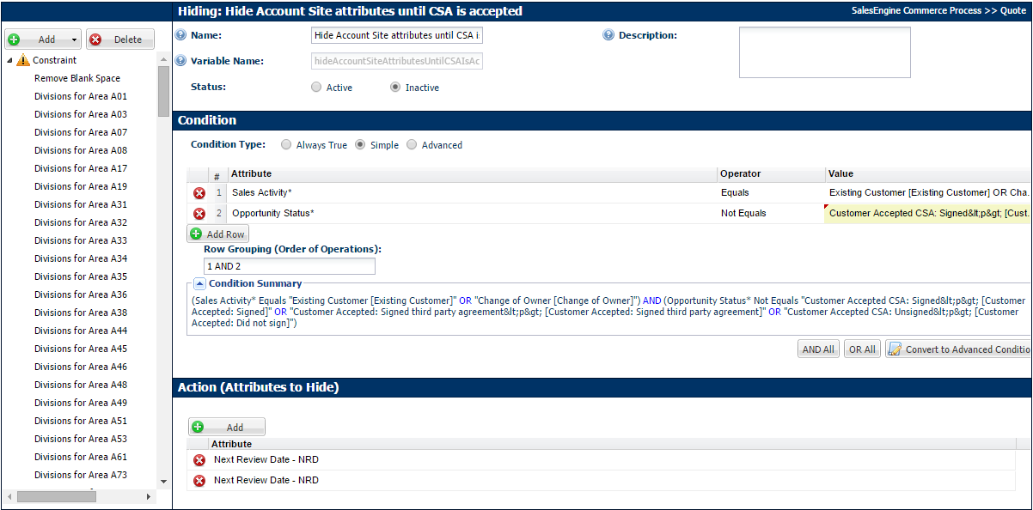

“Set Status”

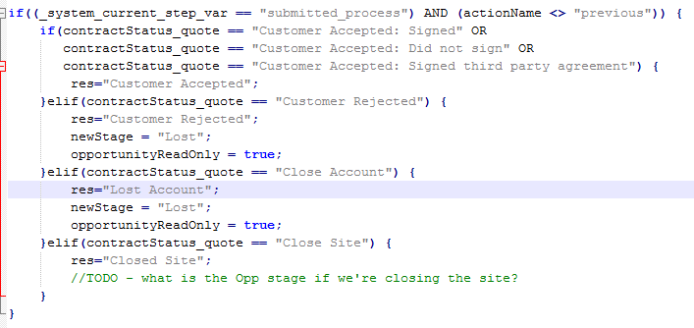  
 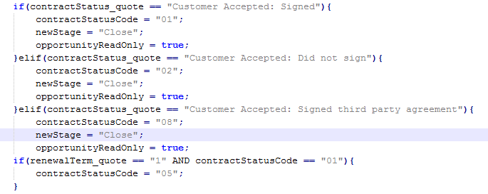

Contract Finalized

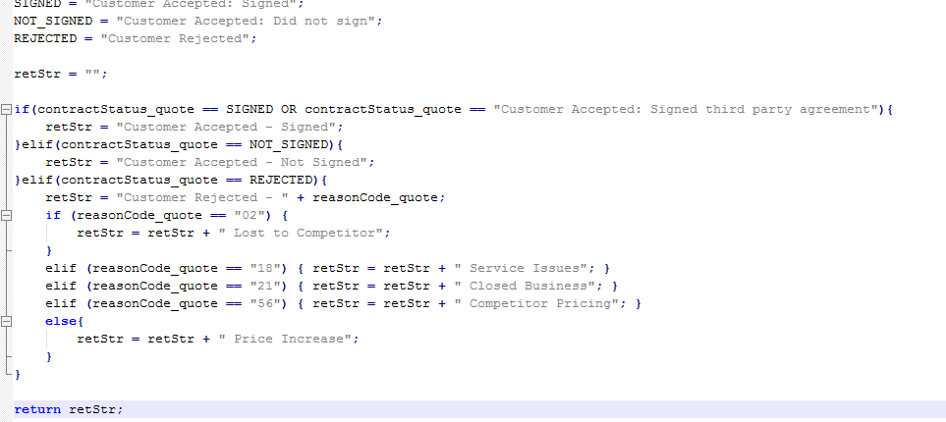

Finalize Contract: Approved to Creating Order (3 Transition Rules)

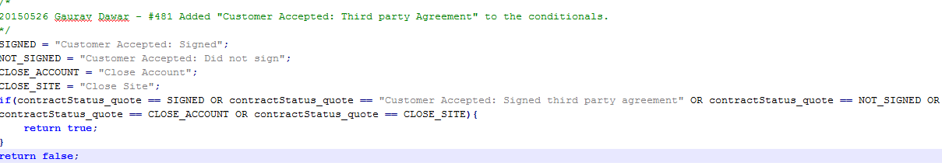

XML:

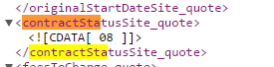

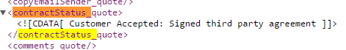

# Impacted Systems (InfoPro, TIBCO and BI)

No new variables hence should not affect InfoPro AAE process but will include InfoPro team on testing as the new value for contract status will be flowing through and it should be programmed for in infopro.

# Report Changes

NA

# Appendix